|  |
| --- |
|  |



**7 June 2013** **The Weekly Bulletin of Rotary Club of Kathmandu Mid-Town** **Bc-7.6/012-13**

**District : 3292 Web: www.rotarymidtown.org.np Club Id : 26776**

**JUNE IS FELLOWSHIP MONTH**

Rotary Fellowships are international, independently organized groups of Rotarians, Rotarian spouses, and Rotaractors who share a common vocation or recreational interest. Rotary Fellowships give their members the opportunity to have fun, make new friends around the world, and enhance their experience in Rotary.

Friday, 31 May:

Guest Speaker Rtn Krishna M Gautam provided an interesting presentation on issues of ageing population, "Ageing in the 21st Century: A Celebration and a Challenge". In fifties and sixties, population explosion was the major issue, and world focus was on measures on population control. With advent of medical technology, health consciousness and reduced birth rate, the increasing proportion of ageing population has been the major issue of both developing and developed worlds. But very little attention has been given to address the soon-to-be-very-problematic issue. Within next a few decades world scenario of the living population will be quite different than what it is at present. The Speaker is of the view that concrete action plans need to be developed at all levels – national as well as international, to address the issue of ageing population. Although there was a conspicuous absence of anything on the issues of aging population in the UN's first MDG's it is high time that UN starts planning in including specific plans and programs in the next MDG's. During the question/answer session, Rtn. Kulchandra Gautam, who is the past Assistance Secretary of UNO informed that on 30 May 2013, a UNO committee has recommended the Secretary General for inclusion of ‘Demographic Change’ as an agenda while formulating the next ‘Millennium Goal’.

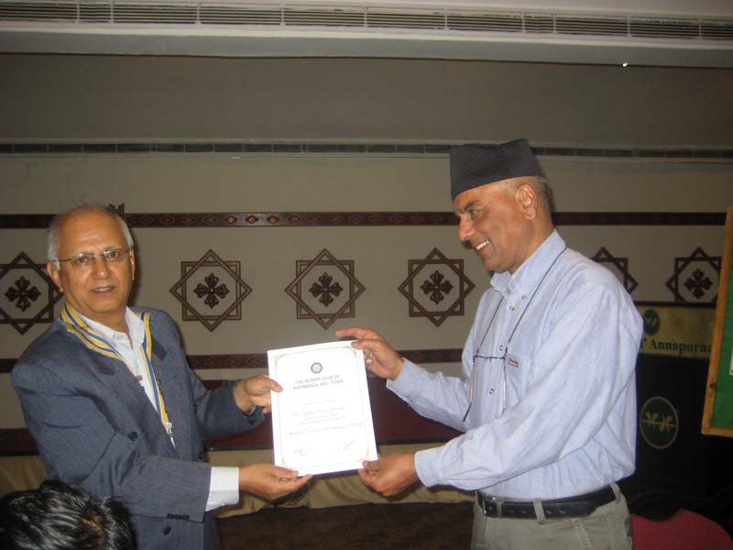

*In the picture President Devendra handing over a token of appreciation to guest speaker Rtn Krishna M Gautam.*

# Weekly Meetings and Programs :

|  |  |  |
| --- | --- | --- |
| Date | Program/Speaker | Program/Topics of Presentation |
| 7 June 2013 | Karin Puttkammer, NHHO Chief Advisor | Construction of a School Canteen for Higher Secondary School in Chyangli |
|  |  |  |

Friday, 7 June:

Ms Karin Puttkammer will be our guest speaker. She worked as Secretary at University of Bonn, Germany,  Dep. of plant science and retired in June 2010. She is in Nepal since Aug 2010, volunteered for 3 months at German NGO 'Kaule e.V.' in Kakani, a agro-forest project; She has been associated with the project since then; She is chief-advisor at a Nepali NGO – Nepalese Humanitarian Help Organization, since Sept 2011. She speaks Nepali fluently. In her presentation at the Club meeting, as a guest speaker, she will be sharing her experience of constructing a school canteen for High School students in a remote area.

**Feeling young at 70 - Adult Living:**

"You're only as old as you feel."

Many expressions like this float around in the steamy lowlands of our mundane lives. And I guess they may be true -- for some people, but I contest such hackneyed platitudes. I'm not as old as I feel. When I feel like I'm 18, I'm still 69, going on 70. Feeling doesn't change the age of my body. Not in the least. So maybe it's a question of who I am - which "I" is "I" when "I" feel old or young on any given day.

Nevertheless, feeling like 18 can change my attitude toward my body and ultimately, my health. But that doesn't make me 18 again.

We seniors get duped into believing a lot of old age drivel simply because we grew up with it, never questioned it, and have a hard time accepting the reality of what we see in the mirror. It's as if there's some kind of personal glory in denying the age of the body and all its aches and pains. We want to impress people with our platitudinous wisdom.

That's why old people don't say they feel old. When you ask them how old they feel, they say five, or 10, or maybe 16, but never 65 or 75--not unless their bodies are afflicted with aging problems that give them little or no peace of mind.

Sometimes I feel as if I'm a five-year-old boy. Sometimes I feel the way I did when I was 12. I often feel as if I'm 18--in the prime of my life again. I have vivid memories of being 25, 30, 40, and 52, but for most of my adult life, I've felt as if I were still 18. Not all the time, but when I think about it.

I don't expect anyone to remember my first article for this column (three or so years ago), but it was about maturity and what it means to mature with age. Like Eleanor Rigby, we all have a jar of faces at the door, ready to put on for whatever occasion comes next, and for the most part, we all leave the little kid in us at home when we go out. When I check this out for myself, I see that it's true. Part of me never grew up, and I'm embarrassed not to act my age when I'm in public. And when I look beyond the invisible walls of my own psyche, I see that it's true for most other people as well.

And what's it all about? Forget the Peter Pan syndrome and the "child within." It has nothing to do with that. It's more about the fact that our emotional lives never matured -- were never intentionally educated. We learned to mimic a lot of adult behaviour, but mimicking what we think is adult behaviour is not the same as actually having a mature emotional function. How many times has someone snapped at you, "Oh, for Pete's sake, grow up!"

Hardly anyone has a truly mature emotional function. In youth, we educated our brains, and even some parts of our bodies, but there was never much input into our emotional lives. (In fact, our justice system refuses to accept evidence based on emotional experience. It doesn't know how to measure the truth of feelings.)

So, I'd guess that for me, in relation to the ages I've cited above, I had some strong emotional impressions at those times in my life, and I can easily connect with them in old age because they were strong. But since I've begun studying this aspect of my life, I can see that learning to be the same age in body, feeling, and mind is no small task.

Dan Racicot retired from teaching in Toronto in 1997 and moved back to Sudbury to begin a second career in creative learning styles. In 2003, he opened Mountaintop Enterprises, which focuses on freelance photography, writing and publishing, and the promotion of men's studies. More information at [*www.mountaintop.ca*](http://www.mountaintop.ca)

*Source:* Daniel Racicot /Internet News

**Committee Chairpersons' Column:**

**???**

**Past Presidents' Column:**

Club Meeting Minutes !

Confirming minutes of the earlier week meeting is only a ritual process, indeed !

On Friday 31 May morning, as usual, President Devendra moved meeting minutes # 1180 (held on 24 May) for adoption, there was clapping, and minutes adopted.

On 24 May the regular meeting was conducted by PP Komal. Why ? President Devendra was absent? There was nothing stated in the minutes.

President Devendra was nor granted 'leave of absence' !

It seemed neither President Devendra nor Joint Secretary Pramod thought it necessary to mention anything on the absence of President on that day, in the minutes ??

PP RR Shrestha

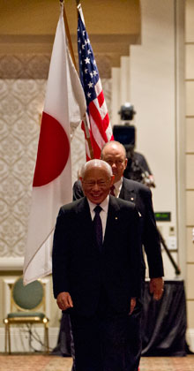

Peace can mean freedom of thought and of speech, freedom of opinion and of choice, and

the ability for self-determination. It can mean security, confidence in the future – a life and

home in a stable society. On a more abstract level, peace can mean a sense of happiness, of

inner serenity, of calm.

**RI President Sakuji Tanaka**

**On lighter side** :

Click here ⇩



**A Thought for the Day:**

***Your absence should be long enough so that somebody misses you,***

***it should not be so long that somebody finds out that***

***how well he/she can do without you..!***

**Great Quotes:**

***A person without a sense of humor is like a wagon without springs***

***jolted  
by every pebble in the road***

Henry Ward Beecher

*courtesy:* Rtn Dr Isabella C Bassingana Khadka

NB: Send any informations/photos that may be of interest to the Club or Rotarians in general to

BC Editor: RR Shrestha email: rryesrr@gmail.com

## 7 June 2013 The Weekly Bulletin of Rotary Club of Kathmandu Mid-Town bc-7.6/012-13

.